Requirement Specification



|  |
| --- |
| **Table of Contents** |

Requirement Specification 1

1.0 Introduction 3

1.1 Purpose 3

1.2 Scope 3

1.3 Background 3

1.4 Business Objectives 3

2.0 Solution Overview 4

2.1 Data Warehouse Architecture 4

2.2 Data Warehouse Schema 4

# Introduction

## Purpose

The purpose of this document is to clearly define the solution architecture of the Data Warehouse. Data Warehouse is required to store the data and for performance reporting as output.

## Scope

The in-scope development is the process needed to extract data from each BU, transform the data, and store the data in data warehouse.

## Background

Currently each BU has their own database and several support data only exist at the ERP. It would be difficult for them to make a relation with ERP data and also when the overview reporting for all business units needs to be generated.

Each BU is looking for a solution to integrate all of data that make them easier to do the analysis and generate reports.

## Business Objectives

The high-level business objectives for the project are to:

1. Build a single source of truth
2. Deliver detail information for each BU
3. Deliver overview information for all BU combined

# Solution Overview

## Data Warehouse Architecture

The architecture consists of 4 layers:

1. Data source layer
2. Data staging layer 🡪 Copies of source system tables
3. Data storage layer 🡪 Integrate, historize, and transform the data from the different source systems
4. Data presentation layer 🡪 Structure the data in a way that is accessible to consumers

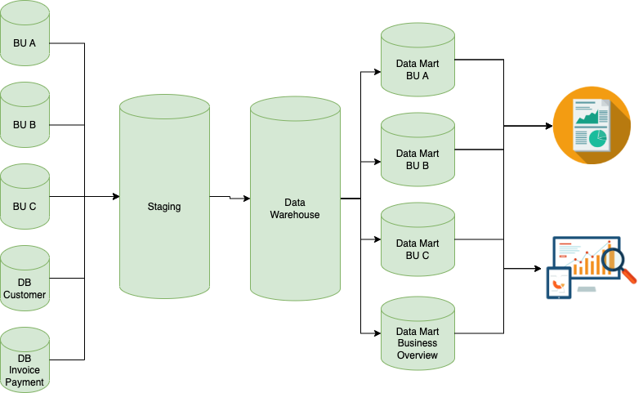

Figure 1 - Data Warehouse Architecture

## Data Warehouse Schema

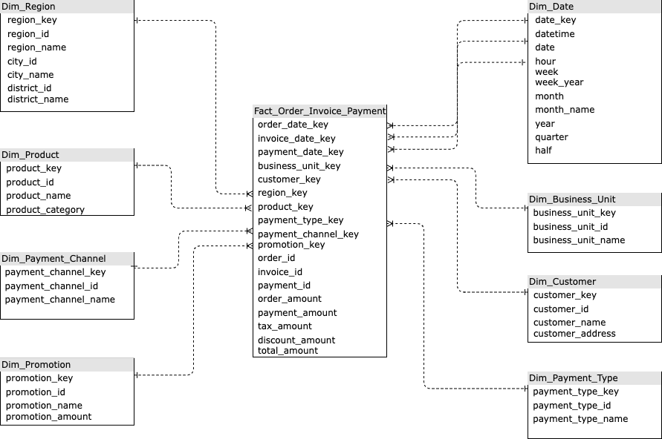

Figure 2 - Data Warehouse Schema

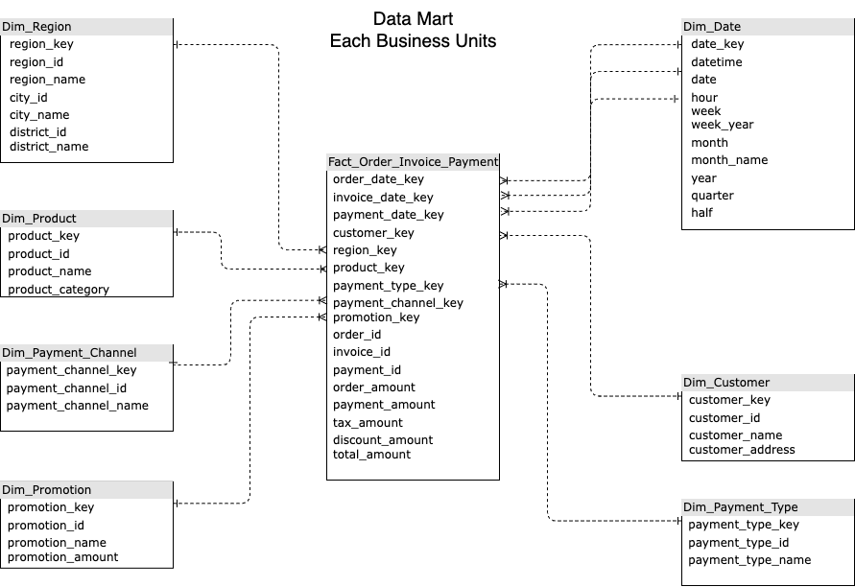

Figure 3 - Data Mart BU

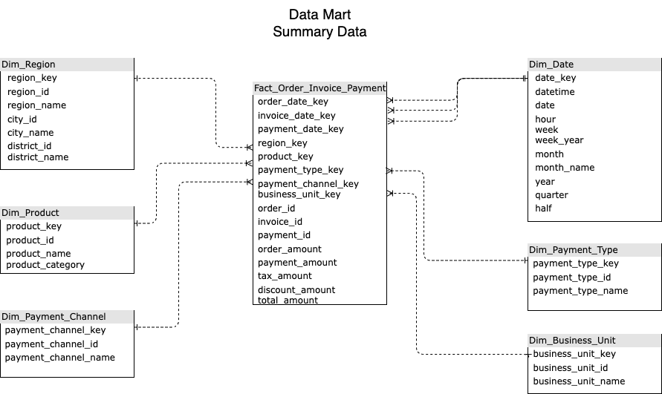

Figure 4 - Data Mart Business Overview